ASSIGNMENT: Circuits ACT

FILE: Circuits_ACT_Team45.pdf

DATE: 4 March 2016

BY: Kathryn Atherton

katherto

Joshua Hahn

Hahn28

Hannah Mackin Schenck

hmackins

SECTION: 03, 1:30-3:30

TEAM: 45

ELECTRONIC SIGNATURE:

Kathryn Atherton

Joshua Hahn

Hannah Mackin Schenck

The electronic signatures above indicate that the document submitted for evaluation is the combined effort of all team members and that each member of the team was an equal participant in its creation. In addition, each member of the team has a general understanding of all aspects of the document.

**TASK 1:**

PART A:

Overview

PART B:

|  |  |  |  |
| --- | --- | --- | --- |
| R1 | R2 | Voltage Placement | Voltage |
| 2 kOhms | 4.7 kOhms | A -> B | 1.4796 |
| 2 kOhms | 4.7kOhms | B -> C | 3.4754 |
| 2 kOhms | 4.7kOhms | A -> C | 4.958 |

1. Vb is V1 + V2. V1 / R1 = V2 / R2.
2. No energy loss. Vb must be lost completely in V1 and V2. The current through the branches should be equal.

PART C:

|  |  |  |  |
| --- | --- | --- | --- |
| Pin 1 | Pin 2 | Slider Position | Resistance |
| 1 | 3 | 25% from right | 9.235 |
| 1 | 3 | 75% | 9.235 |
| 2 | 3 | 25% | 2.74 |
| 2 | 3 | 75% | 9.257 |
| 1 | 2 | 25% | 1.07 |
| 1 | 2 | 75% | 9.257 |

1 to 3 does not change, but 1 to 2 and 2 to 3 have changes in resistance from right to left.

1. The further from 1 and 2, the higher the resistance.
2. The voltage does not change as the position moves; only the current changes.

PART D:

1. As the variable resistance increases, the current decreases, the voltage through the variable resistor increases, the voltage through the LED decreases, and the power through the LED decreases.

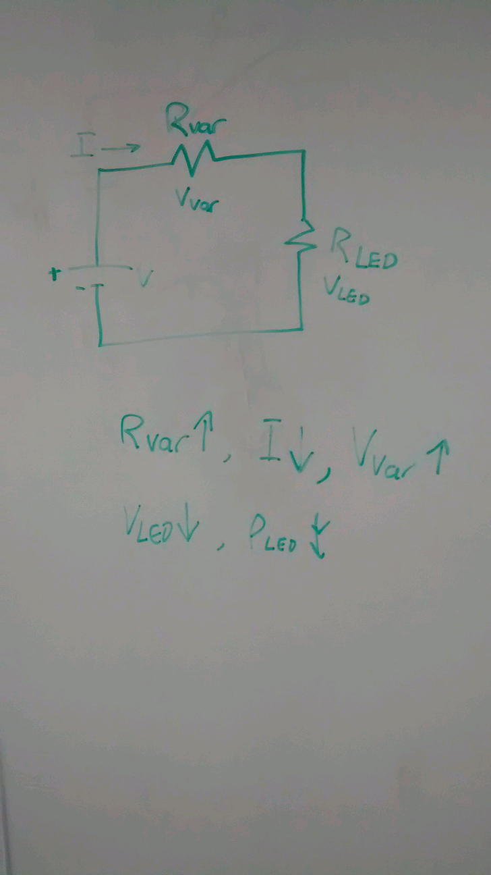

1. The brightness is proportional to the power and power is equal to the current times the voltage.

**TASK 2:**

PART A:

|  |  |
| --- | --- |
| Stretch | Resistance |
| 4 cm | 0.9 kOhms |
| 4.3 cm | 0.9 kOhms |
| 5.2 cm | 1.25 kOhms |
| 6 cm | 1.57 kOhms |
| 8 cm | 2.27 kOhms |

PART B:

|  |  |
| --- | --- |
| Stretch | Voltage |
| 4 cm | 1.5 V |
| 4.5 cm | 1.87 V |
| 5 cm | 2.02 V |
| 5.5 cm | 2.11 V |
| 6 cm | 2.21 V |
| 6.5 cm | 2.38 V |
| 7 cm | 2.47 V |

Voltage = 0.1471 ( stretch ) + 1.4914

When the 10 kOhm resistor was used, the voltage decreased 5 fold.

PART C:

1. All the resistances must be the same, and close to the resistance of the stretch sensor.

|  |  |
| --- | --- |
| Stretch | Voltage |
| 4 cm | 2.06 V |
| 4.5 cm | 1.94 V |
| 5 cm | 1.88 V |
| 5.5 cm | 1.83 V |
| 6 cm | 1.77 V |
| 6.5 cm | 1.70 V |
| 7 cm | 1.63 V |

PART D:

Machine control to measure speed (the faster it goes, the further it stretches)

**Measure weight (distance stretched = weight)**

1. **If something is too heavy, it could break the sensor**
2. **The voltage is not always constant (batteries depleating over time)**
3. **Over time, the properties of the resistor may change**
4. **Not very precise**
5. **Lots of calibration**

**TASK 3:**

PART A:

|  |  |
| --- | --- |
| Distance | Resistance |
| 1.5 cm | 0.18 kOhms |
| 2 cm | 0.19 kOhms |
| 2.5 cm | 0.21 kOhms |
| 3 cm | 0.25 kOhms |
| 3.5 cm | * 1. kOhms |

1. As light is increased (distance decreases), resistivity decreases.
2. For the stretch sensor, as the distance increases, the resistivity increases. For the photo cell, as the light increases, the resistivity decreases. External stimuli affect the resistivity of both sensors

PART B:

|  |  |
| --- | --- |
| Distance | Voltage |
| 1.5 cm | 0.089 V |
| 2 cm | 0.138 V |
| 2.5 cm | 0.144 V |
| 3 cm | 0.155 V |
| * 1. cm | * 1. V |

Voltage = 0.0346 (distance) + 0.0521

PART C:

|  |  |
| --- | --- |
| Distance | Voltage |
| 1.5 cm | 2.18 v |
| 2 cm | 2.09 v |
| 2.5 cm | 1.78 V |
| 3 cm | 1.77 V |
| * 1. cm | * 1. V |

Voltage = -0.236(distance) + 2.504

PART D:

Determine rate of photosynthesis (amount of light)

**Distance from sun on rocket ship**

1. **Not that sensitive**
2. **Hard to obtain calibration data**
3. **Giant photocell needed**
4. **Shadows, dust, etc.**

**TASK 4:**

PART A: